# RESUME

Telephone : 0111 6872081 Email : camillia1601@gmail.com

Address : F-10-02, Pangsapuri Pandanmas 2, No 6, Lorong Delapan

Kampung Pandan 55100 Kuala Lumpur

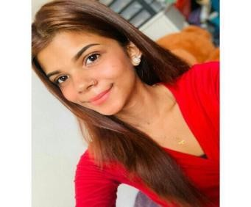

Name : Camillia Lynette Richard

Objectives : Having a stable and challenging career that uses my personal capability and creativity where I can enhance my skills and improve my knowledge

PERSONAL PARTICULAR

# Age : 22 years old

Date of birth : 16 January 2001

## Nationality : Malaysian

Religious : Catholic

Gender : Female

Marital status : Single

NRIC No : 010116-14-1462

## Height : 165cm

Weight : 40kg

ACADEMIC BACKGROUND

Primary Education :

(2008 – 2013)

Level : Ujian Peperiksaan Sekolah Rendah (UPSR)

## Year : 2013 Course : -

Institution : Sekolah Kebangsaan Cochrane

Secondary Education :

(2014 – 2018)

Level : Penilaian Menengah Rendah (PMR)

## Year : 2016 Course : -

Institution : Sekolah Menengah Kebangsaan Cochrane

Level : Sijil Peperiksaan Malaysia (SPM)

Institution : Sekolah Menengah Kebangsaan Cochrane

WORKING EXPERIENCE

I have no experience but i’m able to catch up and learn things fast .

# SKILLS

Computer Skills : Microsoft Office Application (Microsoft Word,

Microsoft Excel, Microsoft PowerPoint, etc)

Social skills : Assistant Monitor

: Secretary Christian Fellowship

: Class Monitor

Language Skill : English

: Excellent speaking and writing

## (Excellent / Good) : BM

: Fair speaking and writing

IMMEDIATELY CAN JOIN .