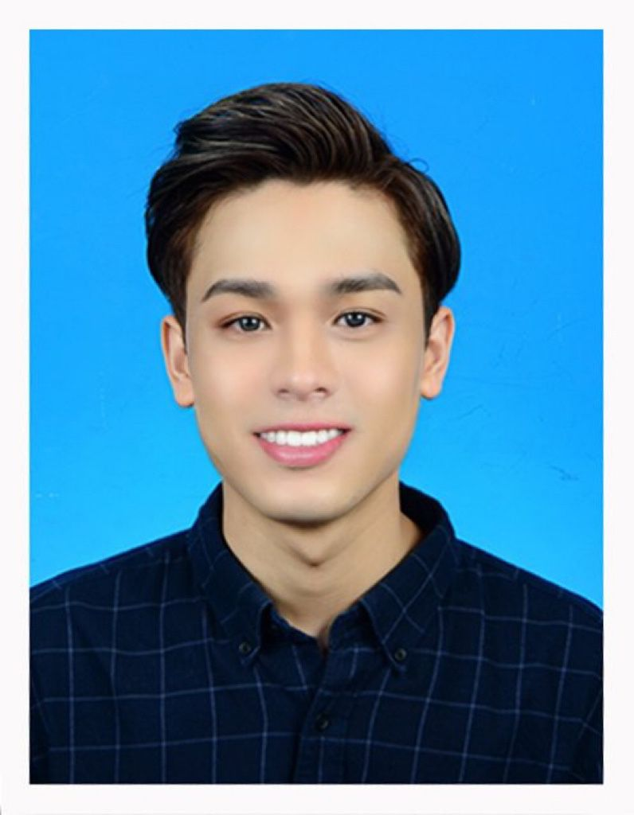

MUHAMAD HAKIMI BIN MUHAMAD DERAFIN

Email: [hakimim659@gmail.com](mailto:hakimim659@gmail.com) | Mobile: +6019-9184142

**PERSONAL PROFILE**

I am a hardworking, honest individual. I am a good timekeeper, always willing to learn new skills. I am friendly, helpful and polite, have a good sense of humour. I am able to work independently in busy environments and also within a team setting. I am outgoing and tactful, and able to listen effectively when solving problems.

**HIGHLIGHTS**

* Communication
* Empathy
* Patience
* Technical knowledge
* Motivation
* Coordination
* Times Management

**EMPLOYMENT HISTORY**

# NADIRA GLOBAL EMPIRE (Troieka) – Sales & Customer Service January 2021 – Present

* meeting with clients virtually or during sales visits
* demonstrating and presenting products
* maintaining accurate records
* attending trade exhibitions, conferences and meetings
* reviewing sales performance
* negotiating contracts and packages
* working towards monthly or annual targets.

# ANDY MALEK LEGACY – Personal Assistant Executive & Communication January 2019 – December 2020

* Monitoring a reporting manager’s email and responding if required
* Preparing communications on behalf of a manager
* Answering phone calls
* Organizing travel and itineraries
* Organizing and planning meetings
* Taking notes and writing minutes during meetings
* Conducting or preparing any research that the reporting manager may require
* Various ad hoc requests

# DYXY COSMETIC SDN BHD – Executive Event & Customer Service Advisor January 2018 – December 2018

* Overseeing and developing floor service operation standard.
* Maintaining quality to serve customer directly thru face-to-face or telephone and electronically communication.
* Work with other departments to solve issue and define requirements plan to improve the customer service process flow to meet quality, reliability, cost, and facilities requirements.
* Ensure the standard of Junior Officers are well managed with the right model reflecting to them.
* Maintain and analyse customer feedback and understand the database to report efficiently to organization in order to focus of the issue with impactful solution.

Achievement:

1. Successfully functions and events in Hua Hin, Thailand.
2. Successfully established Sale increasing 40% of the sale normal sale in Malaysia.

**EDUCATION HISTORY**

**International Collage of Yayasan Melaka** *(class of 2016)*

**Professional Certificate of Cabin Crew -** Overall Classification: **Completed**

My core modules included:

skills and knowledge on cabin crew as well as customer analysis procedures from various sources, risks assessment and prevention in travel and tourism. Simultaneously, this program reflects the roles of individuals who coordinate and maintain the customer service satisfaction in airport, airlines and hotels. Individuals would possess a sound theoretical knowledge base and use a range of specialized, technical or managerial competencies to plan, carry out and evaluate their own work and the work of others. Students will be exposed to information about practical gestures including communication skills, etiquette and reactions that could happen to passenger as a result of their working activities in any airlines and airport.

**Sekolah Menengah Kebangsaan Bandar Maharani** *(class of 2013)* **Sijil Pelajaran Malaysia (SPM) -** Overall Classification: **Completed** My core modules included:

* Malay Language,
* English Language,
* Islamic Studies,
* History,
* Mathematics,
* Science,

**INTERESTS**

Swimming, hiking, and travelling